LADDER REGISTER / INSPECTION CHECKLIST
LADDER NUMBER
LOCATION
LADDER TYPE:
(Step/Single/Extension/Combination)
CONSTRUCTION MATERIAL:
(Plastic/Timber/Metal/Fiberglass)
LOAD RATING:
If you answer “Yes” to any question, please record the information on the Hazard Register, form 14c
 | Yes | No | Yes | No | Yes | No | Yes | No | Yes | No
RAILS:
(Are they cracked, bent, split or frayed)
TOP CAP:
(Is it cracked, loose or missing)
STEPS/RUNGS:
(Are the steps/rungs loose, cracked, bent or missing)
LOCKS:
(Is the lock loose, bent, broken or missing)
SPREADER:
(is the spreader loose, bent or broken)
HARDWARE/FASTENERS/RIVETS:
(Are any missing, loose, rusted or broken)
HINGES:
(Are any hinges loose, bent or missing)
WELDS:
(Are any welds cracked and/or damaged)
LADDER SHOES/FEET:
(Are the shoes/feet worn, broken or missing)
ROPE AND PULLEY:
(Is the rope and pulley loose, frayed or broken)
PLATFORM:
(Is the platform loose, bent, broken, corroded or missing)
LABELS:
(Are the labels missing or not legible)
GENERAL:
(Does the ladder have rust, corrosion or other defects)
NEEDS REPAIR/REPLACEMENT
TRANSFERRED TO ACTION PLAN
INSPECTED BY: | DATE: |  |  |  |  | WORKSITE:
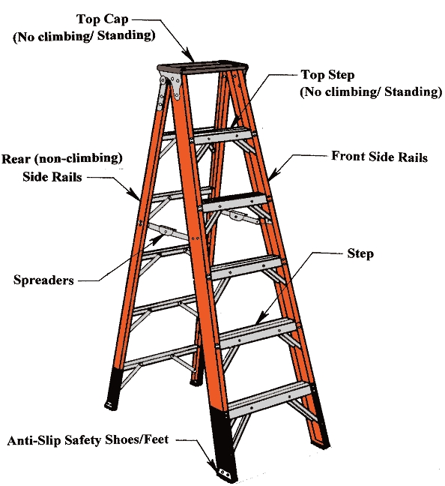
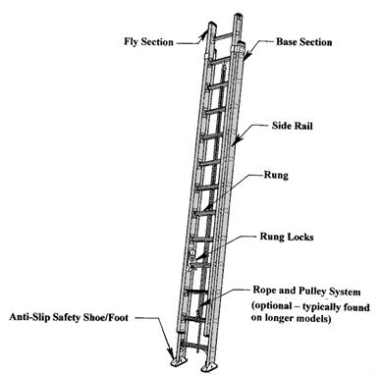
PARTS OF A STEP LADDER

PARTS OF AN EXTENSION LADDER

