Asbestos Procedure (4) V5
Version Control & Change History
Version | Approved by | Approved Date | Reason for Development of Review | Next Review Date
V7 | Sector Forums | 2014 | Legislation – New WHS Act | 2016
April 2015 – Document consolidated across CCES sectors
V1 | Executive Manager CSHWSA | 20/04/2015 | Procedure Consolidation | 2016
V2 | Executive Manager CSHWSA | 22/08/2016 | Review Due | 2019
V3 | Executive Manager CSHWSA | 22/01/2021 | Reviewed content, Updated template. | 2023
V4 | Executive Manager CSHWSA | 26/02/2021 | Updated information for air monitoring | 2023
V4.1 | Executive Manager CSHWSA | 29/04/2021 | Updated information when identifying or disturbing & added Emergency Response Procedure Flowchart. Removing of Friable Asbestos | 2023
V5 | Executive Manager CSHWSA |  | 5.2 Risk of exposure in case of exposure dot point three added the information from dot point six and deleted dot point six.  5.3.1 Asbestos Register, aligned with code of practice.  Hyperlinked references to other sections in procedure.  5.4.8 Discovery of / or Disturbance of ACM removed in addition labelling where applicable.  6.2 Forms & Tools, referenced Asbestos Process Flowchart (022T) | 2026

Approved for Publication: |  | Date:
 | Debbie Nation
Contents
1. SCOPE 3
2. DEFINITIONS 3
3.1. Information 3
4. RESPONSIBILITIES 3
5. PROCEDURE 4
5.1. Identification 4
5.2. Risk of exposure 4
5.3. Controls 5
5.3.1. Asbestos register 5
5.3.2. Asbestos Management Plan 6
5.3.3. Inspection / labels 6
5.4. Removal / Disposal 7
5.4.1. Asbestos Licence 7
5.4.2. Friable Asbestos 7
If exposure is suspected refer to sections 5.2 Risk of exposure & 5.4.8 Discovery of / or Disturbance of ACM. 7
5.4.3. Non-friable asbestos removal 7
If exposure is suspected refer to sections 5.2 Risk of exposure & 5.4.8 Discovery of / or Disturbance of ACM. 8
5.4.4. Asbestos removal control plan 8
5.4.5. Informing removal of asbestos 8
5.4.6. Personal protective equipment (PPE) 8
5.4.7. Air monitoring 9
5.4.8. Discovery of / or Disturbance of ACM 9
5.4.9. Soil contamination 10
5.4.10. Disposal of ACM 11
5.4.11. Demolition / Asbestos removal – impact to site 11
5.5. Instruction and training 11
5.6. Records 11
5.7. Review 12
6. RELATED SYSTEM DOCUMENTS 12
6.1. Policies & Procedures 12
6.2. Forms & Tools 12
7. REFERENCES 12
7.1. Internal Resources 12
7.2. External Resources 12
8. AUDITABLE OUTPUTS 13

PURPOSE
To provide a systematic process for the management of Asbestos, Asbestos Containing Material (ACM) and Asbestos-contaminated Dust or Debris (ACD).

SCOPE
This procedure applies to all Catholic Church Endowment Society Inc. (CCES) workplaces and includes:
- CCES workers and any other person who CCES is directly responsible for or who is impacted by CCES work
- Other duty holders who carry out work for CCES or those likely to be affected by safety issues relating to asbestos.

DEFINITIONS
Definitions can be found on the Catholic Safety Health & Welfare SA Website.

Information
Any building built before 31 December 2003 that does not contain asbestos is required to have a signed document from the builder or competent person that indicates that no ACM was used in the construction of the building.
Any building built after 31 December 2003 is not required to have an Asbestos Register.

RESPONSIBILITIES
Specific responsibilities for carrying out certain actions required by the CCES, have been allocated to position holders within the organisation. Such responsibilities are consistent with the obligations that the legislation places on officers, managers, supervisors, workers and others in the workplace.
Responsibility, authority and accountability processes have been defined in Responsibility, Authority & Accountability Procedure (12), and summarised in:
- Responsibility, Authority & Accountability Matrix – Workers (025G);
- Responsibility, Authority & Accountability Matrix – Managers & Supervisors (023G);
- Responsibility, Authority & Accountability Matrix – Officers (024G); and
- Work Health & Safety and Injury Management Policy.
You are required to familiarise yourself with this procedure in order to understand the obligations that you may have in relation to its implementation and to carry out your assigned actions and responsibilities.
This Procedure is to be read in conjunction with your Organisational Policies and / or Procedures.

PROCEDURE

Identification
A person with management or control of a workplace must, so far is reasonably practicable:
- ensure that all asbestos or ACM at the workplace is identified by a competent person
- assume material is asbestos or ACM if it cannot be identified but a competent person reasonably believes it is asbestos or ACM and
- assume asbestos is present if part of the workplace is inaccessible and it is likely to contain asbestos or ACM.
If asbestos or ACM is in good condition and left undisturbed, it is unlikely that airborne asbestos will be released into the air and the risk to health is extremely low. It is usually safer to leave it and review its condition over time. However, if the asbestos or ACM has deteriorated, has been disturbed, or if asbestos-contaminated dust is present, the likelihood that airborne asbestos will be released into the air is increased.

Risk of exposure
When deciding if there is a risk to health from asbestos, consider whether the asbestos or ACM is:
- in poor condition
- likely to be further damaged or to deteriorate
- likely to be disturbed due to work practices carried out in the workplace or
- in an area where workers are exposed to the material.
A documented risk assessment must be undertaken when carrying out asbestos work or asbestos related work.
For all requirements relating to exposure and health monitoring and analysis of any identified ACM refer to: How to Manage and Control Asbestos in the Workplace.
In the case of exposure (over the exposure standard) to any person from asbestos containing dust the following must occur:
- contact Catholic Safety Health & Welfare SA (CSHWSA) immediately
- send the person for medical treatment
- organise for health monitoring to be conducted as soon as possible and ensure all health monitoring requirements are met in line with the Work Health & Safety Regulations 2012 (SA).
- record the exposure on the incident database and investigate the reason for exposure, identify the root causes and implement appropriate control measures. Refer to Incident Reporting & Investigation Procedure (2)
- record the persons details on the National Asbestos Exposure Register.

Controls

Asbestos register
Persons Conducting a Business or Undertaking (PCBU) must ensure an asbestos register is prepared by a competent person and kept at the workplace. An asbestos register is a document that lists all identified (or assumed) asbestos in a workplace. The asbestos register is intended to ensure workers and others in the workplace do not accidently disturb asbestos. The asbestos register must be maintained to ensure the information in the register is up to date and reviewed and updated at least five (5) yearly by a competent person.
The asbestos register is a document that lists all identified (or assumed) asbestos in a workplace. The asbestos register must record any asbestos or ACM that has been identified or is likely to be present at the workplace from time to time. This would include:
- the date on which the asbestos or ACM was identified (or assumed)
- the location, type, and condition of the asbestos; or − state that no asbestos or ACM has been identified at the workplace if the person knows that:
- asbestos or ACM has not been identified (or assumed) to be present at the workplace, and
- asbestos or ACM is not likely to be present from time to time at the workplace.
A comprehensive asbestos register may also include: − details of any asbestos assumed to be in the workplace − results of any analysis that confirms a material at the workplace is or is not asbestos − dates when the identification was carried out − details of inaccessible areas, and − details of any past asbestos removal work. It may also be useful to attach photographs or drawings to visually show the location of the asbestos or ACM in the workplace. be reviewed and where necessary revised by the PCBU (or a competent person engaged by the PCBU) if:
- the asbestos management plan is reviewed
- further asbestos or ACM is identified at the workplace
- asbestos is removed from or disturbed, sealed or enclosed at the workplace or
- refurbishment or demolition work is to be undertaken.
be readily accessible to
- a worker who has carried out, carries out or intends to carry out work at the workplace
- health and safety representatives who represent workers that carry out or intend to carry out work at the workplace
- a PCBU who has carried out, carries out or intends to carry out work at the workplace and
- a PCBU who has required, requires, or intends to require work to be carried out at the workplace.

Asbestos Management Plan
An Asbestos Management Plan (AMP) sets out how asbestos or ACM that is identified at the workplace will be managed. Each worksite must develop a written AMP. The AMP must include the following information:
- the identification of asbestos or ACM
- decisions, and reasons for decisions, about the management of asbestos
- procedures for detailing accidents, incidents or emergencies involving asbestos or ACM.
The AMP must be readily accessible to any worker who intends to carry out any asbestos work and reviewed at least once every five (5) years by a competent person, or when:
- there is a review of the asbestos register or a control measure
- asbestos is removed from or disturbed, sealed or enclosed at the workplace
- the plan is no longer adequate for managing asbestos or ACM at the workplace.
A sample Asbestos Management Plan (006T) is available.
For further information relating to the requirement for an AMP refer to: How to Manage and Control Asbestos in the Workplace.

Inspection / labels
All identified ACM must be inspected annually and documented, either in the asbestos register or the Asbestos Inspection Form (018F) to ensure that:
- the ACM warning labels are in place and legible
- there is no damage or deterioration of the ACM.
It is recommended that digital photographs are taken of the ACM during each inspection. Labels may be affixed to all areas where asbestos material may exist, (e.g., eaves, switchboards, floor lining etc.,) or have the use of a single label at the entrance to the site to indicate the presence of asbestos (it must be clearly visible) and direct persons to the asbestos register prior to commencing work.
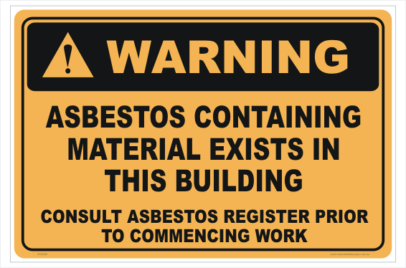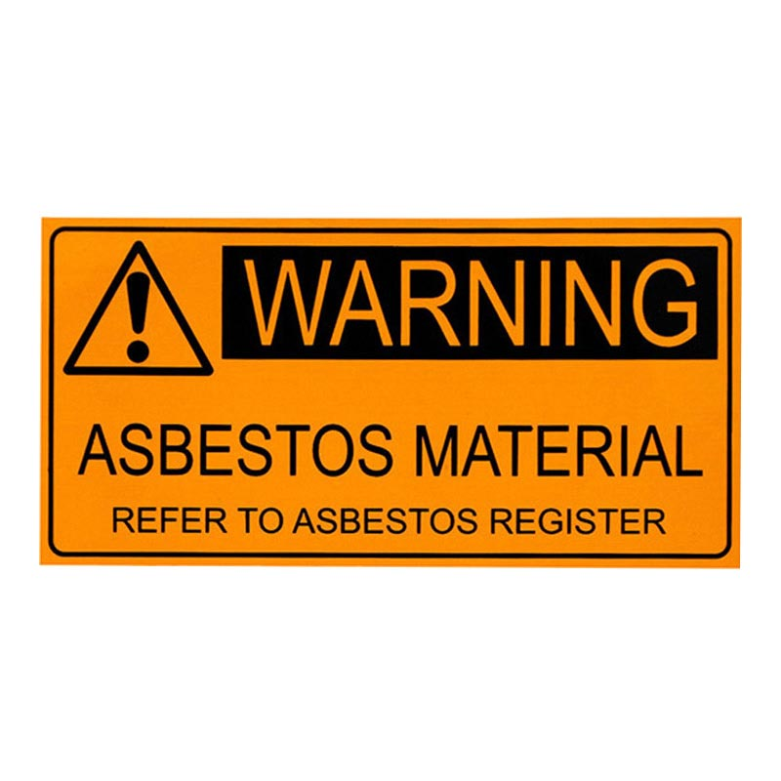

Removal / Disposal

Asbestos Licence
A PCBU who commissions the removal of asbestos at the workplace must ensure asbestos removal work is carried out only by a licenced asbestos removalist, unless the WHS Regulations specify that a licence is not required (less than 10m²).
There are two (2) types of licences: Class A and Class B.
Class A can remove any amount or quantity of asbestos or ACM or ACD.
Class B can remove any amount of non-friable asbestos or ACM including associated ACD.

Friable Asbestos
Any asbestos containing material that is in a powder form or that can be crumbled, pulverised or reduced to a powder by hand pressure when dry, can only be removed by an A Grade licensed asbestos removalist and air monitoring must be conducted by an independent licensed asbestos assessor, refer section 5.4.7. Air monitoring.

If exposure is suspected refer to sections 5.2 Risk of exposure & 5.4.8 Discovery of / or Disturbance of ACM.

Non-friable asbestos removal
- any work undertaken on ACM must be in accordance with: How to Manage and Control Asbestos in the Workplace.
- ten (10m²) square metres or less: (approximately the size of a small bathroom). A licence is not required to remove ten (10m²) square metres or less of ACM. For further information please refer to: How to Safely Remove Asbestos.
- greater than ten (10m²) square metres: The removal of asbestos greater than ten (10m²) square metres must be carried out by a licensed asbestos removalist. For licensed removal work a clearance certificate is required before the work area can be reoccupied for ordinary use; and air monitoring must be conducted by an independent licensed asbestos assessor refer section 5.4.7. Air monitoring.
- asbestos Containing Dust (ACD): A Licence is not required to remove any ACD that is not more than a minor contamination and is associated with the removal of ten (10m²) square metres or less of non-friable asbestos.

If exposure is suspected refer to sections 5.2 Risk of exposure & 5.4.8 Discovery of / or Disturbance of ACM.
A current listing of licensed asbestos removalists can be obtained from the SafeWork SA website.

Asbestos removal control plan
The asbestos removal control plan must be prepared by a licensed contractor prior to the asbestos removal. The asbestos removal control plan must:
- be kept at the workplace until the completion of the asbestos work
- be readily accessible on-site for the duration of the licensed asbestos removal work to:
      - PCBU’s at the workplace
      - workers or their health and safety representatives; and
      - the occupants of the premises (if the work is carried out in residential premises)
- be made available for inspection under the WHS Act.

Informing removal of asbestos
Prior to removal of ACM:
- workers and any other person must be informed of the removal and when the work is to commence
- other business or residence in the immediate surrounding vicinity must be informed
- by agreement, the notification can be by either the PCBU or the licensed removalist
- signs alerting workers are in place to indicate asbestos removal work
- barricades are erected to delineate the asbestos removal area.

Personal protective equipment (PPE)
PPE will need to be used in combination with other effective control measures when working with asbestos. Further requirements detailed in procedure Personal Protective Equipment Procedure (30).

Air monitoring
Air monitoring involves collecting air samples to assist in assessing the levels of airborne asbestos fibres present in either:
- the asbestos removal area to assess the effectiveness of controls (control monitoring); or
- the workers’ breathing zone to assess exposures to asbestos (exposure monitoring).
Air monitoring may be required when:
- friable asbestos is removed
- non-friable asbestos 10 square metres or greater is removed
- it is not clear whether new or existing control measures are effective
- there is evidence (for example, dust deposits are outside the enclosure) the control measures have deteriorated because of poor maintenance
- modifications or changes in safe work methods have occurred that may adversely affect worker exposure or
- there has been an uncontrolled disturbance of asbestos at the workplace.
A PCBU, including licensed asbestos removalists, must ensure that the exposure standard for asbestos is not exceeded at the workplace.
Where air monitoring has been conducted then a clearance certificate must be obtained and kept with the asbestos register.

Discovery of / or Disturbance of ACM
Report to management immediately if material has been discovered or disturbed that is known or suspected to contain asbestos. The area must be immediately evacuated and secured to prevent persons from entering. The sites CSHWSA WHS Consultant must be immediately contacted. The Officer of the worksite must contact a competent person for verification. If confirmed that it is asbestos, then an assessment must be undertaken to determine the appropriate course of action. This action may include removal or repair and amending the asbestos register will be required.
Refer to Emergency Response Procedure flowchart below.

EMERGENCY RESPONSE PROCEDURE

Soil contamination
If the soil is suspected of containing asbestos, the worksite must:
- cease work immediately and make the area of suspected contamination safe (e.g., bunt area off, signage)
- ensure a competent person takes samples of the material for analysis to confirm.

Disposal of ACM
- asbestos waste may only be disposed of at an Environment Protection Authority (EPA) rubbish dump that is licensed to accept ACM waste
- asbestos waste should be collected in heavy duty 200µm polythene bags that are not more than 1,200mm long 900mm wide or wrapped
- bags must be labelled with an appropriate warning stating that they contain asbestos, and that dust creation and inhalation should be avoided
- for further information on the disposal of ACM please refer to: How to Safely Remove Asbestos Code of Practice.

Demolition / Asbestos removal – impact to site
Before demolition commences a documented risk, assessment must be completed. Control measures that are developed and implemented will reduce the exposure of workers or persons in the vicinity of the demolition site to below the asbestos exposure standard.

Instruction and training
- inform workers of this procedure at induction as required
- any worker who is to remove or work on ACM is provided with the appropriate training which is provided in a way that is readily understandable
- training records for the worker are to be kept five (5) years after the day the workers ceases working for the PCBU.

Records
Documents used to manage asbestos as prescribed by this procedure will be produced in a format that allows tracking for verification and review and be in accordance with requirements detailed in Document Control Procedure (23).
Worksites must ensure that they retain documents in a legible and good condition for a period of forty (40) years from LAST entry. This includes all documents, including images relating to:
- asbestos registers
- asbestos work/removal documentation
- air-monitoring
- sampling.
- exposure documents
- copies of permits/licenses
- clearance certificates

Review
This procedure will be subject to a planned review by the document owner in accordance with the requirements outlined in Document Control Procedure (23).

RELATED SYSTEM DOCUMENTS

Policies & Procedures
Audit Procedure (7)
Consultation & Communication Procedure (5)
Contractor Management Procedure (6)
Document Control Procedure (23)
Hazard Management Procedure (14)
Incident Reporting & Investigation Procedure (2)
Personal Protective Equipment (PPE) Procedure (30)

Forms & Tools
Asbestos Inspection Form (018F)
Asbestos Management Plan (006T)
Asbestos Process Flowchart (022T)

REFERENCES
Legislation and other requirements related to this procedure are defined in Group Legal Register (010T) which can be accessed via the Catholic Safety Health SA website.

Internal Resources
Responsibility, Authority & Accountability Matrix – Managers & Supervisors (023G)
Responsibility, Authority & Accountability Matrix – Officers (024G)
Responsibility, Authority & Accountability Matrix – Workers (025G)

External Resources
Work Health and Safety Act 2012 (SA)
Work Health and Safety Regulations 2012 (SA)
SafeWorkSA:
How to manage and control Asbestos in the Workplace Code of Practice
How to Safely Remove Asbestos Code of Practice
www.asbestos.sa.gov.au

AUDITABLE OUTPUTS
The following examples will be used to verify implementation of this procedure:
- Asbestos Management Plan
- Asbestos Inspection Form
- Asbestos Register
- Asbestos Risk Assessment
- Air monitoring records
- Asbestos clearance certificates
- Asbestos removal control plan
- Training records

