Site / Area: |  |  |  | Date of assessment: |  | Risk Assessment #: | 109RA
Completed by (name): |  |  |  | Signature:
In Consultation with |  |  |  | Signature:
Identify / describe activity, equipment, area or event you are assessing: |  |  |  |  | Drone (model aircraft or remotely piloted aircraft (RPA))
In conjunction with this risk assessment, training / education and development of a relevant SOP may be required.
 | Step 1: Identify the hazard/s:  What do you believe are the hazards?  (Refer Risk Assessment Guideline (015G)) |  | Step 2: Assess the risks:  What do you believe are the risks?  (Refer Risk Assessment Guideline (015G)) |  | Step 3: Reducing the risk:  What do you believe can be done to reduce the risk?  (Refer Risk Assessment Guideline (015G))
 | What could cause harm? |  | What could go wrong? |  | Controls
 | INDOOR USE
 | Machinery & Equipment:  - Being hit by moving object:  - Drones hitting people/objects when airborne  - Propellers falling off in-flights  - Drone failure (loses power) |  | - Lacerations  - Contusions  - Bruising  - Damage to eyes |  | - Drones selected are small in size (less than 2 kg) with limited risk to people. Have propeller guards.  - Teachers provide safety rules at beginning of the activity.  - Limit the distance to people and provide trained teacher supervision at all times.  - Only one drone to be flown at all times. Event area is partitioned into testing and flying zones.  - Eye protection to be worn whilst Drones are in operation.  - Ensure batteries are fully charged prior to operating the drone.
 | Electricity  - Frayed / loose cords  - Water on electrical equipment |  | - Electrocution  - Electric shock  - Fire |  | - Inspect 240V charging cords for damage.  - Regularly tested and tagged (check its done within last 12 months)  - RCD’s checked regularly.
 | Gravity  - Slips, trips and falls |  | - Sprains / strains |  | - All furniture, obstructions moved out the way when using the drone
 | Psychological |  | - Anxiety |  | - Appropriate staff / student ratios in place.  - Where special needs students are participating, staff familiar with the students and have strong relationship with them will directly supervise those students. Withdrawal plan in planned for students who require withdrawal to a safe place.
 | Machinery & Equipment  - LiPo Batteries – self-combustion resulting in fire |  | - Smoke inhalation  - Burns  - Death |  | - Fire extinguishers readily accessible.  - Emergency Management Procedures implemented.  - Never store loose batteries together. The batteries’ terminals may contact one another, causing a short circuit.  - Never charge batteries near flammable items or liquids. DO NOT leave unattended when charging.  - Do not use if damaged or swollen.  - Never store batteries in extreme temperatures or direct sunlight. The battery should be stored within -10℃~45℃ range environmental condition.  - Always disconnect batteries when not in use and store batteries in a non-conductive and fireproof container (e.g. LiPo bag).  - Never alter, puncture or impact Batteries or related components.  - Remove any extension connectors (example below) prior to storing or charging your LiPo battery  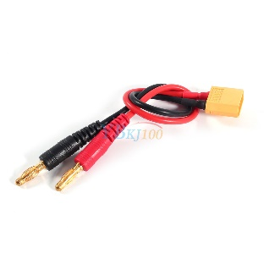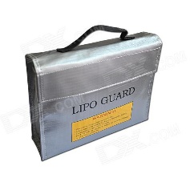  - Always use a fire proof LiPo safety bag (e.g. picture above), or other fire proof container when you are charging, discharging, or storing your LiPo batteries. While LiPo fires are rare, they can happen incredibly quickly and can do a lot of damage. All it takes is an internal short circuit to set the battery off. There is no way to predict when it will happen. It does tend to happen more often when batteries are fully charged, being overcharged, or while being discharged, but it can happen to any LiPo at any time.  - Never fill the container to capacity with your batteries, always follow manufacturer recommendations on LiPo bags for how many mAh’s it can safely contain.
 | OUTDOOR USE (risks as detailed above)
 | Electricity  - Windy conditions, resulting in hitting power lines |  | - Electrocution / electric shock  - Disruption to power supply |  | - Must not fly drone higher than 120 m above ground level.  - Must be kept at least 30 m away from other people.  - Only one drone to be flown at all times.  - Drone must be kept within visual line-of-sight.  - Must not fly over or above people or in a populous area (this includes beaches, parks, sports ovals where is a game in progress).  - No recording people without their consent.  - If drone weighs more than 250 grams, you must fly at least 5.5 kms away from a controlled airport, which generally have a control tower at them.  - You must not fly in a way that creates a hazard to other aircraft, so you should keep at least 5.5 km away from airfields, aerodromes and helicopter landing sites.  - Drone can only be flown during the day and must not be flown through cloud or fog.  - Ensure no power-lines are within 30 m.  - DO NOT OPERATE ON WINDY DAYS.
 | For further information, check out this link https://www.casa.gov.au/aircraft/landing-page/flying-drones-australia
Authorised by: |  | Signature: |  | Date:
Review hazard/risk assessment if task or circumstances change and at intervals appropriate to the level of risk (minimum 5 years).

Step 4: Monitor & review:
(Refer to hazard sheet)
Please tick Yes or No
Were the controls effective? |  |  |  | Were there any unforeseen hazards/ incidents? |  |  |  | New controls
Yes |  | No |  | Yes |  | No
DETAILS |  |  |  | DETAILS |  |  |  | DETAILS
Name: |  | Signature: |  | Date:

